
Project Title:
AI Model to Predict Student Dropout Risk
Submitted by:
Musa Bin Abdullah 233576 Muhammad Danial 233588
Muhammad Musa 233598 Abdullah Altaf 233558
Group No:
09
Course Name:
Artificial Intelligence (CS344)
Department:
Computer Science
Semester & Year:
Fall 2025
Submitted to:
Madam Atika
Contents:
1. Introduction: 3
2. Problem Statment: 3
3. Objectives: 3
4. DATASET DESCRIPTION 4
5. METHODOLOGY 5
5.1 Machine Learning Methodology 5
6. Implementation Details 6
6.1 Technology stack 6
7. Results and Discussion 6
7.1 Model Performance 6
7.2 Feature Importance Analysis 6
7.3 Interactive Dashboard Output 7
8. CONCLUSION 7
9. Future Work 7
10. Future Work 8
11. Appendix 8
11.1 Data Overview 8
11.2 Exploratory Data Analysis 9
11.3 Model training and Evaluation 9
11.4 Dropout Prediction 9
12. Evaluation Sheet 10

Project Title:
AI Model to Predict Student Dropout Risk

Introduction:
Artificial Intelligence (AI) is about building systems that can learn from data and make smart decisions. In this project, AI and Machine Learning (ML) are used to solve an important problem in higher education: identifying students who may lose focus and drop out. By studying past student records and demographic information, we created a complete prediction system that finds students who are at risk of dropping out.
This project does more than just build a model. The prediction system is connected to an interactive Streamlit dashboard, which allows teachers and academic staff to easily view results and take action at the right time. The report explains each step of the project, starting from understanding the data to deploying a working web application. It also shows that a well-planned and structured approach is important for success in data science projects.

Problem Statment:
Educational institutions suffer major financial losses due to high student dropout rates. One of the main problems is that current support systems are mostly reactive. Students are usually identified as at risk only after they have faced academic difficulties for a long time, when support is less effective. Manually monitoring hundreds of students using many factors, such as academic performance, socioeconomic background, and enrollment details, is not practical.
This project solves this problem by developing an AI-based early warning system. The system automatically analyzes complex student data and predicts dropout risk in a probabilistic way. It provides real-time and useful insights for counselors and administrators, helping them move from a reactive approach to a proactive and preventive support system.

Objectives:
The core objectives of this project were:

To design and build a reliable machine learning pipeline that can accurately predict student dropout.

To create an easy-to-use and interactive dashboard using Streamlit that shows data insights and provides real-time predictions for academic staff.

To make the model’s predictions understandable by using techniques such as SHAP and LIME, which help build trust in the AI system.

To develop a well-structured and clearly documented project that is easy to reproduce, maintain, and follows MLOps-inspired practices.

4. DATASET DESCRIPTION
The project utilizes the "Higher Education Predictors of Student Retention" dataset. A well-prepared dataset is foundational for any ML project. This dataset contains records for 4,424 students, described by 36 features, with a target variable indicating their final status: Graduate, Dropout, or Enrolled.
Key Feature Categories:
- Academic Performance: First and second-semester grades, curricular units approved, admission grade.
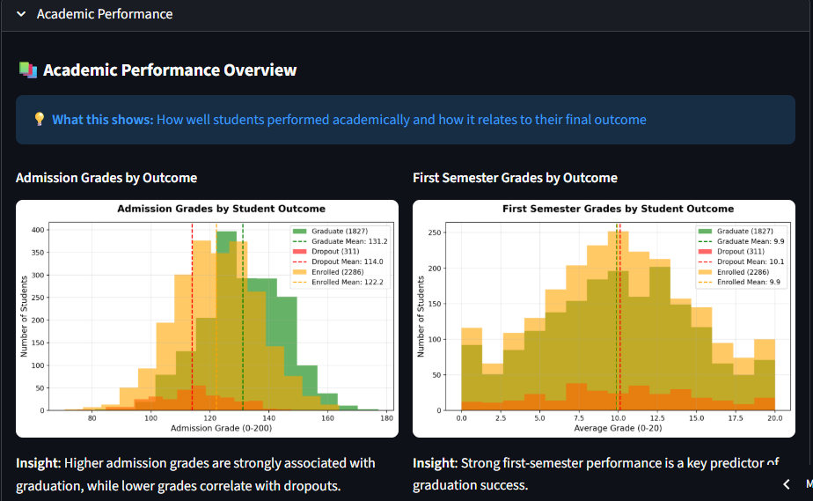
- Demographic & Socioeconomic: Age, gender, marital status, parental education and occupation.
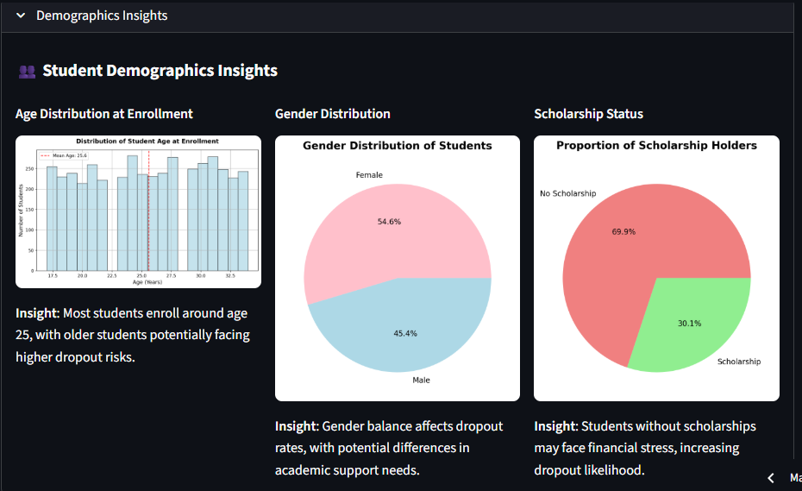
- Financial & Institutional: Scholarship holder status, tuition fee debt, application mode, course choice.
- Macro-economic Indicators: GDP, inflation rate, and unemployment rate at enrollment.
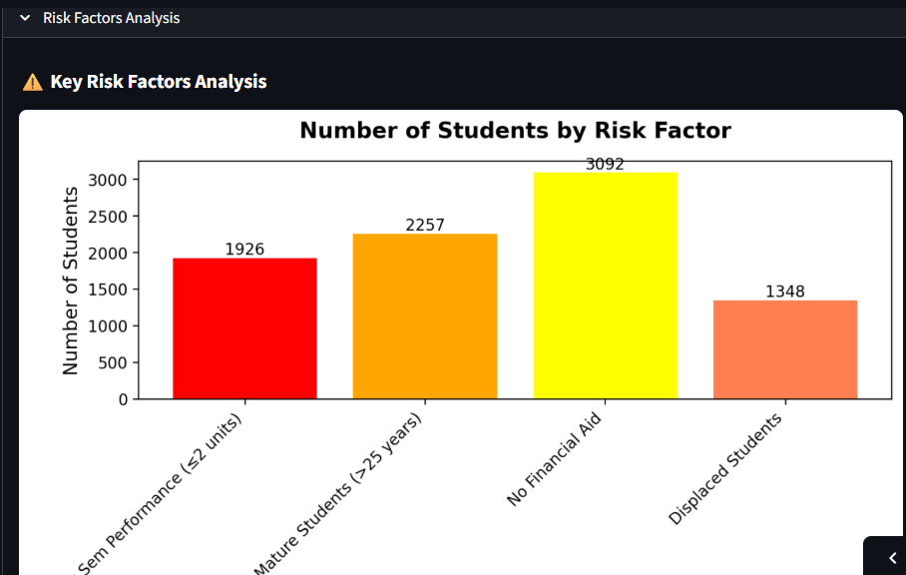
The dataset was clean with no missing values, allowing focus on analysis and modeling. Features like first-semester grades and units approved were hypothesized to be strong predictors, which was later confirmed by feature importance analysis.
What These Numbers Represent
Score Range | Interpretation
0-5 | Low importance –  Features that contribute minimally to predictions
5-15 | Medium importance –  Features that moderately influence predictions
15+ | High importance –  Key features that strongly affect dropout prediction

5. METHODOLOGY

5.1 Machine Learning Methodology
The problem was treated as a multi-class classification task. A Random Forest Classifier was chosen as the main algorithm because it is reliable, works well with different types of data, and provides feature importance, which helps in understanding the model’s decisions.
- Data Preprocessing:
This step included encoding the target labels, handling categorical variables, and dividing the dataset into training (80%) and testing (20%) sets.
- Model Training and Tuning:
The Random Forest model was trained using parameters that help reduce overfitting, such as setting appropriate values for maximum depth and minimum samples required for a split. The model’s performance was then tested using standard evaluation methods.
- Evaluation Metrics:
The model was evaluated using accuracy, precision, recall, F1-score, and a confusion matrix to get a complete view of its performance.
- Interpretability:
To avoid treating the model as a “black box,” SHAP and LIME techniques were used. These methods explain overall feature importance as well as individual predictions, which is important for building trust in the system, especially in an educational environment.

6. Implementation Details

6.1 Technology stack
- Programming Language: Python 3.8+
- Core Libraries:
  - pandas, numpy: Data manipulation and analysis.
  - scikit-learn: For model building, preprocessing, and evaluation.
  - streamlit: For building the interactive web application dashboard.
  - matplotlib, seaborn, plotly: For creating static and interactive visualizations.
  - shap, lime: For model explainability and interpretability.

7. Results and Discussion

7.1 Model Performance

The Random Forest model achieved an overall accuracy of 82.5% on the held-out test set. The classification report showed strong precision and recall for the "Dropout" and "Graduate" classes, while the "Enrolled" class (indicative of ongoing students) was more challenging to predict, which is an expected and logical outcome.

7.2 Feature Importance Analysis

SHAP analysis revealed the most influential features driving predictions. As anticipated, academic performance metrics from the first semester (e.g., "Curricular units 1st sem (grade)", "Curricular units 1st sem (approved)") were the top predictors. Demographic factors like "Father's qualification" also held significant weight, aligning with findings in similar educational studies.

7.3 Interactive Dashboard Output

The Streamlit dashboard successfully provides:
- Data Exploration: Interactive filters and visualizations for demographic and performance data.
- Real-time Prediction: A form where staff can input or select student attributes to receive an immediate risk prediction (Dropout/Enrolled/Graduate) with a confidence probability.
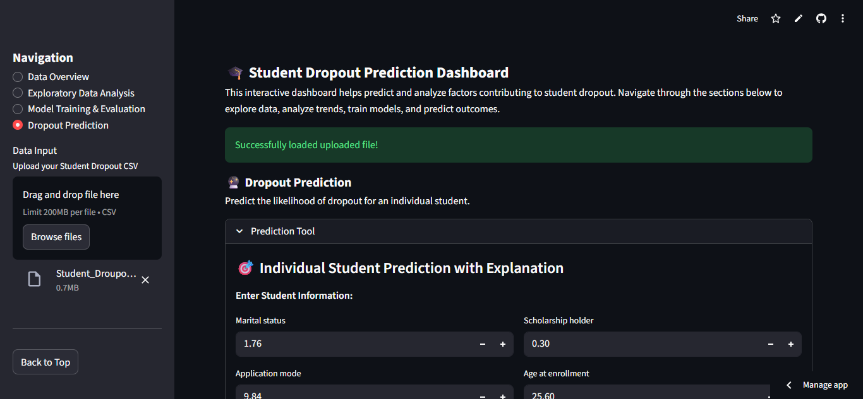
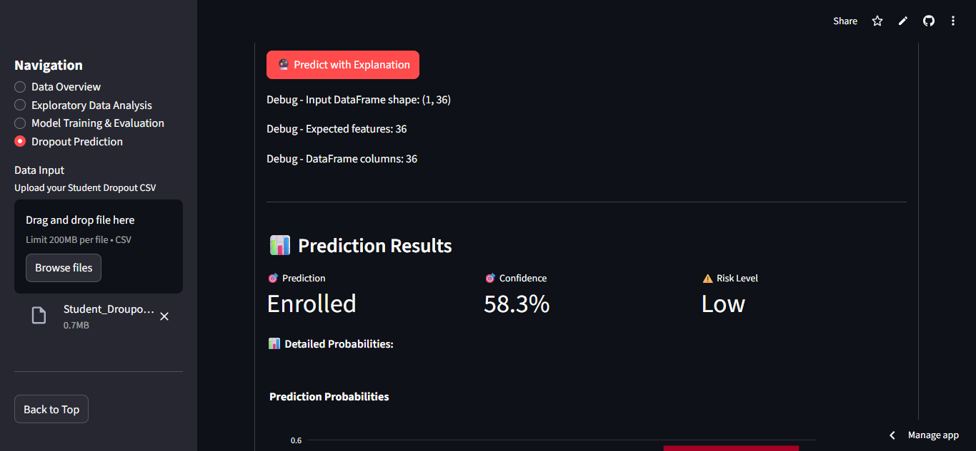
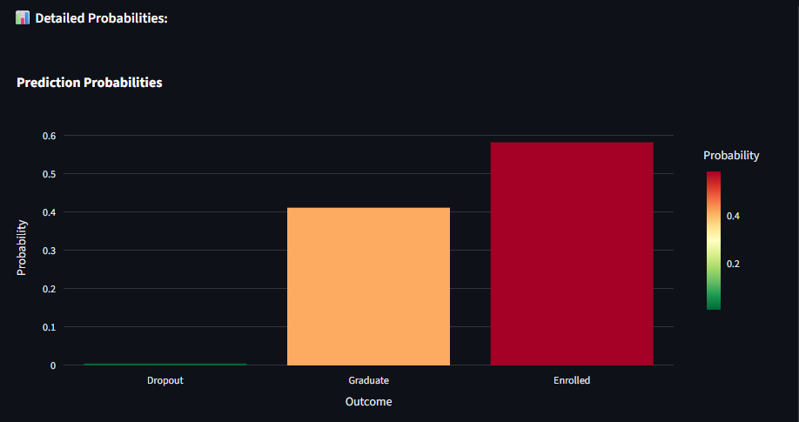
- Model Explanation: For each prediction, SHAP force plots or LIME explanations visually illustrate which features most contributed to the outcome, a vital feature for actionable advising.
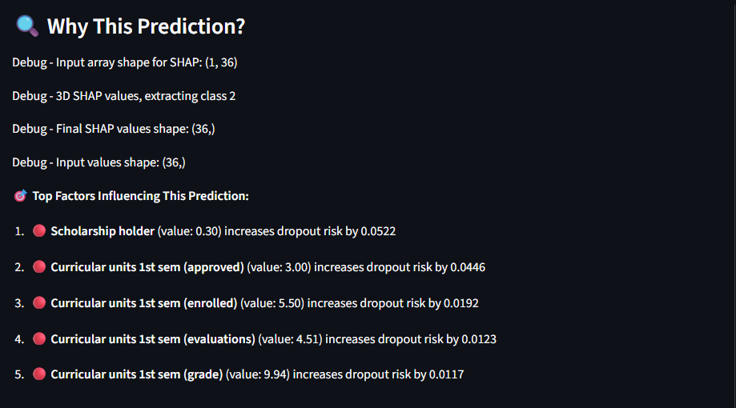
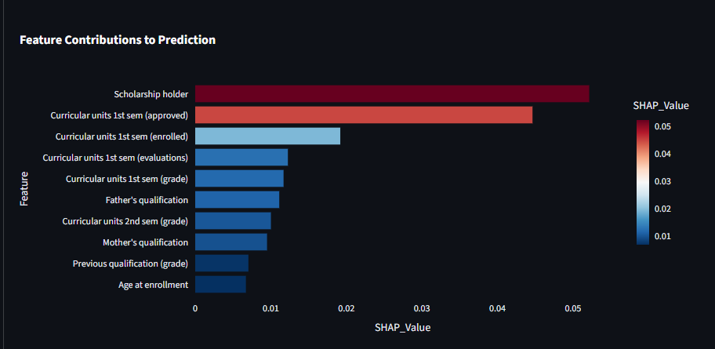
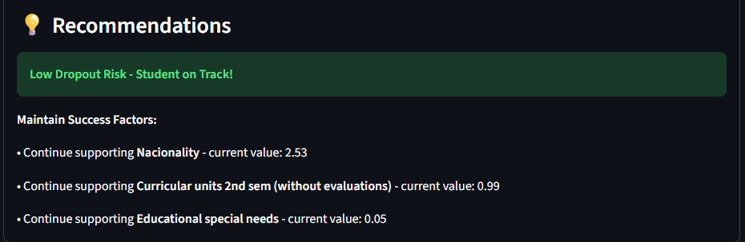

8. CONCLUSION
This project successfully developed a functional AI system for predicting student dropout risk. We implemented a Random Forest classification model with good predictive accuracy and, more importantly, embedded it into an interpretable and user-friendly Streamlit dashboard. The system meets the core objective of providing academic institutions with a proactive tool to identify at-risk students, thereby facilitating timely and potentially retention-saving interventions.

9. Future Work
- Model Enhancement: Experiment with advanced algorithms like XGBoost or LightGBM and sophisticated handling of the temporal sequence of student data.
- System Integration: Transition from a standalone app to a live system integrated with the university's Student Information System (SIS) for real-time data ingestion and alert generation.
- Expanded Analytics: Incorporate natural language processing (NLP) to analyze student interaction data (e.g., course feedback, advisor notes) for a more holistic risk profile.
- Production Deployment: Containerize the application using Docker and deploy it on a cloud platform for scalable, institutional-wide access.

10. Future Work
- Russell & Norvig – Artificial Intelligence: A Modern Approach.
- D'Agostino, A. How To Structure Your Machine Learning Project. Medium.
- Auliyyaai. Saving Students Before It’s Too Late: How We Predicted Dropouts with Machine Learning. Medium.
- Towards Data Science. Structuring Your Machine Learning Project with MLOps in Mind.
- University of Texas at Austin, CS 391L Machine Learning Project Report Format.
- Scikit-learn, Streamlit, SHAP, and LIME official documentation.

11. Appendix

11.1 Data Overview
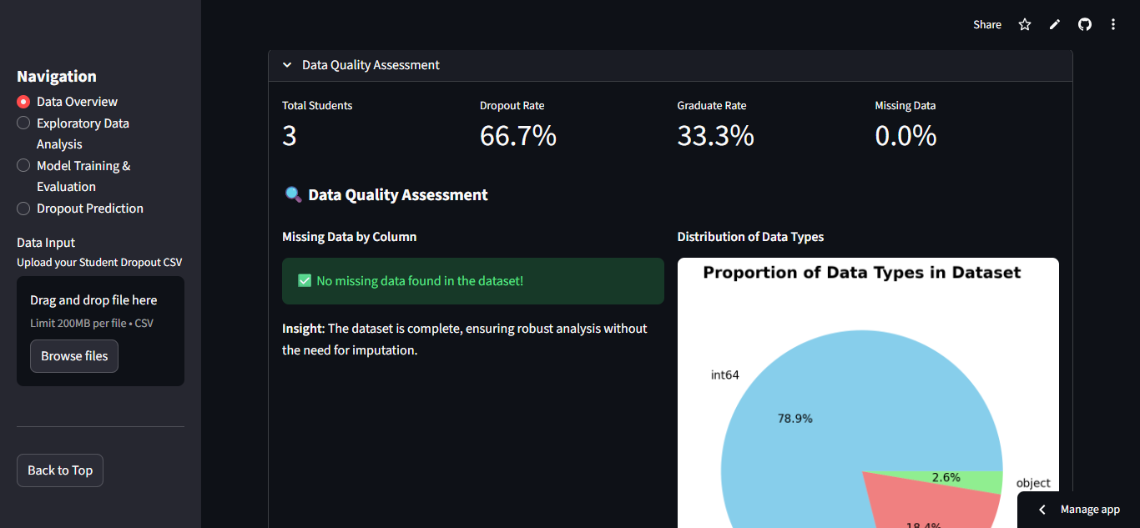

11.2 Exploratory Data Analysis

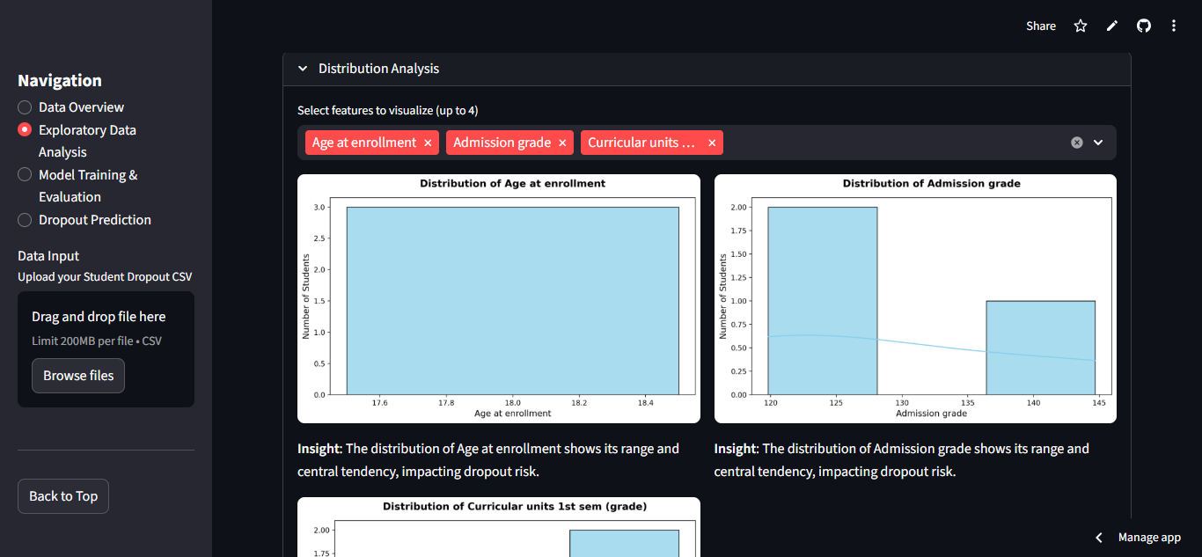

11.3 Model training and Evaluation
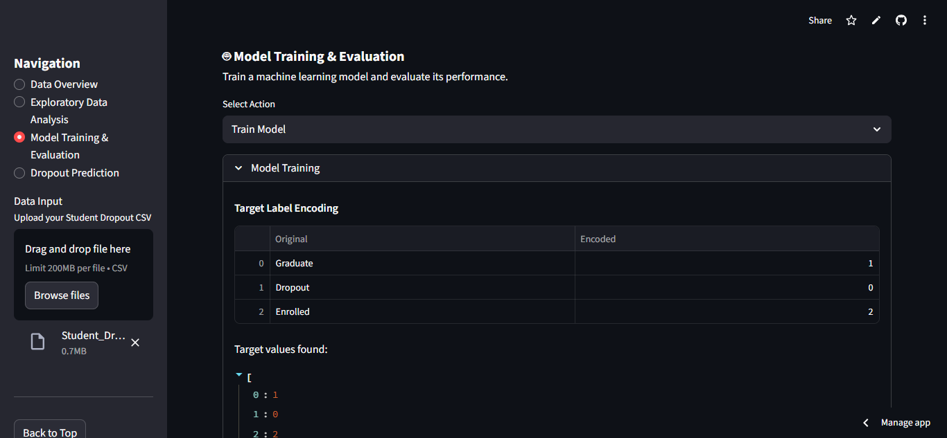

11.4 Dropout Prediction

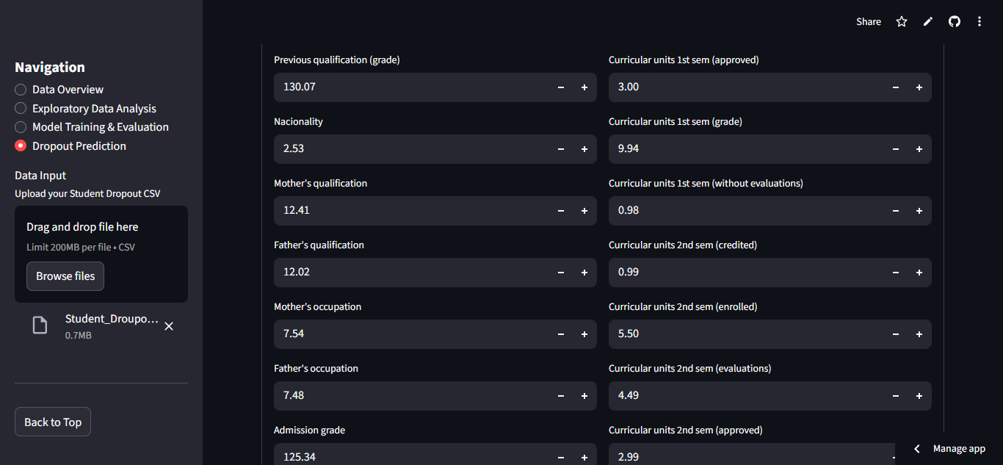

12. Evaluation Sheet
Artificial Intelligence Project Evaluation Rubric
Evaluation Criteria | Excellent (10) | Good (9) | Satisfactory (5) | Poor (2) | Marks
Problem Understanding | Clear & accurate | Mostly clear | Partial | Weak | /10
AI Concept Application | Correct & justified | Correct | Minor issues | Incorrect | /15
Dataset & Feature Design | Well-defined | Adequate | Limited | Poor | /20
Model Implementation | Fully working | Mostly working | Partial | Not working | /30
Results & Analysis | Clear & logical | Adequate | Weak | Missing | /10
Report Quality & Viva | Professional | Good | Average | Poor | /15
Total Marks |  |  |  |  | /100

